Recent Developments in Periodontology with Artificial Intelligence (AI)
Mrs. K. T. Caroline Gnanatheepa
Assistant Professor, Department of Computer Science, S.I.V.E.T. College, Chennai

Periodontal disease, also known as periodontitis, is one of the most frequent oral health problems that has been plaguing society for centuries. Its prevalence continues to rise presently as a result of Oral-Health-Related-Quality-of-Life and changing dietary conditions, resulting in poor oral health, and it is the second leading cause of tooth loss in adults. Prior to the diagnosis, probes and symptoms of illness, radiography images were used. Numerous developments in advanced probing technologies have recently been implemented, and which could be helpful in identifying more accurate measures of pocket depth and clinical attachment loss. Newer radiography procedures have been developed in response to developments in probing devices, providing us with a 3-D perspective of the abnormalities found in periodontal disease. However, the standard protocol or procedure for treating periodontal disease has been scaling and root planning. In the last few decades, new techniques in addition to scaling and root planning have been implemented, which are not only efficient and helpful in eradicating the disease but are also recovering the loss of periodontal tissue as achieved by flap surgeries, for the normal function of the periodontium and the attachment apparatus.
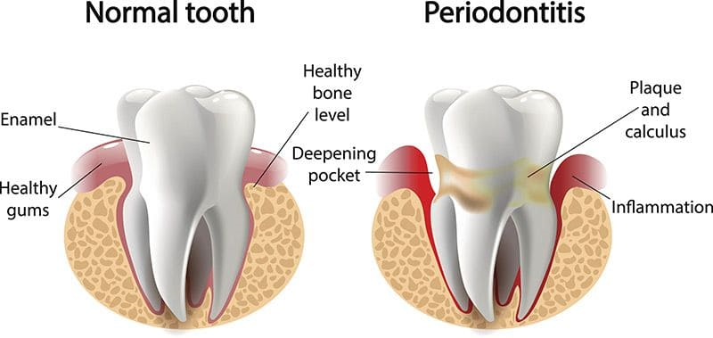

The following are some of the new developments in Periodontology:
- Artificial Intelligence
- 3-D Printing
- Micro dentistry
- Nanotechnology
- Biomarkers for Periodontal Disease
- Therapy Using Stem Cells

- Artificial Intelligence

Analysis of huge amounts of data can be made easier in Artificial Intelligence with the use of computers, software knowledge, and algorithms since they deliver accurate information quickly, making human activities considerably easier.

Artificial Intelligence is being used more frequently across a range of industries as a result of recent advancements in computational understanding and data collecting digitization. Due to its ability to efficiently diagnose and treat a variety of diseases, Artificial Intelligence (AI) has recently gained popularity in the medical and dental fields, or in other words, the healthcare industry. In the discipline of periodontics, a robotic arm known as "PerioSim" is frequently used to assess periodontal pockets by using tactile sensations to determine the difference between soft and hard tissues represented on a visual monitor.

- 3-D Printing

The term "3-D Printing" refers to an additive manufacturing technique that creates layers of materials. It makes an exact reproduction of each product that must be using data from software called CAD those measures hundreds of cross-sections of layers. In recent years, 3-D Printing has attracted a lot of interest from the dental community, because it makes it possible to generate precise, small-batch customised goods at reasonable prices.

Three-dimensional Printing (3-D Printing) is being utilised in dentistry to create personalised impression trays, stone models, prosthetic teeth, and it is also being researched as a way to supply tissue scaffolding for transplantation of bone and ridge augmentation operations in implantology and periodontology.

The operation of 3-D printers is the same as that of conventional laser or as inkjet printers. Using either liquid or powdered resin, a 3-D printer builds an object slowly and layer by layer from an image. The most common use of additive manufacturing which is growing in popularity right now is Bioprinting.

The following categories apply to 3-D Bioprinting methods:
- Extrusion based Bioprinting
- Droplet Bioprinting
- Using Photocuring Bioprinting
- Using Cells Electrospinning Bioprinting

- Micro dentistry

The alternative for standard periodontal surgery, known as periodontal microsurgery, tries to lessen surgical damage while introducing novel chances to improve patient care. Periodontics today uses far less invasive surgical incisions and flap reflection thanks to the implementation of surgical prism loupes or surgical microscopes.

With the development of microsurgical equipment, all surgical movements have been directed by direct vision and reduced to the pinching sensation between the thumb and index finger. A variety of ophthalmic knives, such as lamellar, sclera, crescent, and spoon knives, can be used in periodontics by implementing smaller instruments under magnification enables surgeons to improve their surgical talents and obtain better results. For primary wound healing, 6-0 and 7-0 sutures are applied along with microsurgical incisions.

The Three-Dimensional On-screen Microsurgery System (TOMS), a recent advancement that can replace the operating microscope, enables surgeons to see the microsurgical field in a broad three-dimensional view on a video monitor.

- Nanotechnology

The study, development, and use of structures, devices, and systems through the manipulation of atoms and molecules at the nanoscale is known as nanotechnology. Compared to conventional approaches used for diagnosis, prevention, and therapy, nanotechnology exhibits higher quality and results.

In nanotechnology, bone deficiencies are treated via bone regeneration and scaffold construction using nanomaterials such as carbon nanomaterials, bioactive glass, titanium nanotubes coated dental implants, and most recently the nanoceramics. It has been shown that titanium-coated implants improve the rate of osseointegration, reducing the length of treatment by 1-3 months. Due to their small size, nanoparticles are employed to deliver medications locally to inaccessible locations such the periodontal pocket subgingivally.

Metallic nanoparticles are added to toothpaste or mouthwash to stop the growth of biofilm in the oral cavity. Nanorobots are frequently employed to induce anaesthesia. To develop better products for treating periodontal disorders, further nanotechnology research is constantly being done.

- Biomarkers for Periodontal Disease

Only radiography images and periodontal probes were used to identify periodontal disorders in the past. However, in recent years, biomarkers have been used to diagnose periodontal diseases even in their very early stages, before the condition has just advanced, allowing for the safeguarding of the tooth and prevention of destruction to the periodontium. Biomarkers, a type of diagnostic tool, are traits that can be objectively tested and assessed as indicators of healthy biological processes, pathological processes, or pharmacological reactions to therapeutic interventions.

For the identification of periodontal biomarkers, many chairside kits are available, allowing risk factors to be identified even before symptoms appear. By generating signals when they come in contact with measuring chemical and biological responses, biosensors are also utilized to find specific biomarkers for periodontal disorders.

Modern Technologies like PCR Lab On Chip (LOC), which employs the immunoassay principle. IMPOD (Integrated Microfluidic Platform for Oral Diagnostics), another device that operates on this theory, can accurately and efficiently identify different salivary proteins in small amounts of saliva.

- Therapy Using Stem Cells

The body's pluripotent stem cells have the capacity to differentiate into a wide variety of cell types. The body's repair system is supported by stem cells. SCAP, or stem cells from the apical papilla, are found in the developing roots of permanent teeth. The root dentin is formed in the body by odontoblast-like cells that are produced by these stem cells, or SCAP. SCAP is essential for Apexogenesis. PDLSCs, or periodontal ligament-derived stem cells, are mostly found in the perivascular area of the periodontium. These PDLSCs, which are mostly used in periodontal tissue healing, have features similar to mesenchymal stem cells.

Conclusion:

The integration of Artificial Intelligence into the field of Periodontal disease has ushered in a new era of helping us to understand the root causes of periodontal disease and its risk factors, precision diagnosis, personalized treatment, and enhanced patient care. Clinicians are given invaluable insights thanks to AI's ability to interpret complex dental pictures, predict disease progression, and help with treatment planning that have a chance of major effect in periodontology. However, there is still much to learn in order to get rid of all the obstacles and give us even better tools and methods for the future. As AI continues to evolve, its seamless integration with periodontal procedures offers the potential to revolutionize how we prevent, diagnose, and treat periodontal diseases, thereby improving patient oral health outcomes on a global scale.

