Corn Leaf Diseases Classification using Deep Neural Network classification

¹Mrs.R. Dhivya | ²Dr. N. Shanmugapriya
Research Scholar (FT), Department of Computer Science | Associate Professor & Head, Department of Computer Applications (PG),
Dr.SNS Rajalakshmi College of Arts and Science,. | Dr. SNS Rajalakshmi College of Arts & Science,
Coimbatore-49 | Coimbatore - 49.
divgopal2@gmail.com | spriyanatrajan@gmail.com

Abstract— Corn, one of the most significant agricultural products in the world, is affected by a number of genetic diseases. These diseases cause low productivity and significant financial loss for farmers. Because of this, farmers will benefit from early disease identification by identifying its clinical patterns. This problem is a great application area for computer-aided diagnostic systems due to the long manual disease diagnosis procedure and further information that the accuracy of the identification is inversely correlated with the pathologist's skills. In this paper, we introduced the new hybrid Enhanced EfficientNET with Bidirectional Long Short-Term Memory (BiLSTM) model. The goal of the method is to identify disease categories with different crop plant diseases that are regularly afflicted in this area. Due to this, we developed a dataset of images of corn disease, of which 70% were used for training and had an accuracy of 99.989%.

Index Terms—EfficentNET, BiLSTM, deep neural network, data augmentation, Classification.

- INTRODUCTION
The process of applying various operations to a single image in order to improve it or extract important information is known as image processing. It’s a type of signal processing in which images serves as the input and the result is either a new image or image's characteristics. In today’s world, image processing is one of the most rapidly evolving technologies. It's also a hub of engineering and computer science research [1].
With an estimated global average yield loss every year [1, 2], One of the main reasons why agricultural crops are destroyed is due to plant diseases. Infection, which can be bacterial, viral, or fungal, has a negative impact on plants. The symptoms of these illnesses, which affect leaves, fruits, or branches, can include changes in color, shape, or edges. Investigating potential quick detection, control, and treatment techniques is therefore essential [3-5]. Moreover, growers could use the incorrect chemical or treatment method [6]. The type of infection typically requires analysis and discovery by a plant pathologist, which can be expensive and slow.
The collapse of the crop can be avoided by keeping an eye out for illnesses that affect maize plants. Corn growers typically solely employ manual monitoring; therefore crop failure takes a long time to occur since it is not addressed right away. This method takes a lot of time. Considering the problems, this paper applies scientific discipline of digital image classification to recognize diseases in maize plants by classifying corn plant leaves into groups share specific traits [7].
Several breakthroughs in agriculture are the result of technological advancements. More specifically, apps that use deep learning and artificial intelligence (AI) can be driven by plant photos. Deep learning relies on neural networks that have more layers than just input, result, and hidden layers. The goal of Convolutional Neural Networks (CNNs), a sub-class of deep learning networks, is to discover characteristics and associations in images using a series of convolutional, pooling, and fully connected layer. This layer incorporates the different attributes that the earlier levels have uncovered. CNNs have been demonstrated to be excellent at identifying attributes despite numerous modifications that may impact the source images [8].
The ability to expand agricultural research is provided by improvements in artificial intelligence methods. Machine learning techniques that belong to the deep learning class are currently the focus of ongoing research and have been effectively utilized in a broad choice of fields. Deep learning uses neural networks to extract features, analyze patterns, and classify data [9]. Traditional techniques of manually identifying plant diseases in the agricultural industry require experts to conduct visual inspections, followed by more thorough detection. The retrieved features of different deep learning algorithms can be combined to produce superior results since the classifier will have more descriptive characteristics to draw from, even though every deep learning method can extract attributes in a particular way.
Convolutional neural networks are similar to traditional neural networks in that they consist of neurons with learnable weights and unpredictable behavior. Each neuron takes a few inputs, conducts a dot product, and then, if desired, does non-linearity activation function. The complete neural network signifies a unique differentiable function, from the unprocessed input picture pixels on one end to class scores on the other. They still have a loss function on the last layer (e.g. cross entropy). All of the general neural network parameter learning techniques applies to CNNs as well. CNN architectures are based on the notion that the networks' inputs are images, which allows us to add specific attributes to the architecture.
In this paper, presents an automated Corn Leaf Disease Classification, a novel approach is proposed based on hybrid network by combining Efficientnet with Bi-directional Long Short Term Memory Network Long Short-Term Memory (BiLSTM) model is presented.

- Related Work
(Hue, et al., 2020) [10] presented a convolutional neural network based on data augmentation and transfer learning to find models of maize leaf disease. The approach increases the data through data augmentation to increase the generalization and accuracy of the model before creating a convolutional neural network model based on transfer learning. The convolutional neural network's training is then accelerated using the model, and the test dataset is used to feed the results of the training back into the network.
The effectiveness of three cutting-edge convolutional neural network topologies for classifying maize leaf diseases was evaluated, as (Rocha et al., 2020) [11]. They utilized improvement techniques like data augmentation, Bayesian hyper-parameter optimization, and fine-tuning tactics. The maize leaf images from the PlantVillage dataset are used as the test data for these CNNs, and all experiments were validated using a five-fold cross-validation technique over the training and test sets. The link between the maize leaf classes and the effect of data augmentation in pre-trained models is one of our findings. According to the findings, 97% of all CNN models tested were accurate in classifying maize leaf disease.
Human activities greatly contribute to the global expansion of phytopathological adversities, according to Buja et al. in 2021 [12]. The amount and quality of today's agricultural output, as well as the significance and economic returns, have all decreased as an outcome of pathogen-related food losses. As a result, in plant pathology, “early detection” conjunction among “fast, accurate, and cheap” diagnostics has also become the new maxim, particularly for tough pathogens that increase recognition to asymptomatic individuals with slight primary indications but are then challenging to face. Additionally, in a market that is sensitive to epidemics due to globalization, new technologies designed for field use represent the diagnostic laboratories' new frontier, guaranteeing that the tools and procedures employed are appropriate for the operational circumstances.
A convolutional global pooling neural network was suggested by Xu, et al., 2021 [13] to enlarge the correctness of identifying corn illnesses. First, a convolutional layer and novel Inception section are introduced to the AlexNet model to improve the ability of AlexNet attributes extraction. After that, the authors employed the global pooling layer to take the place of the unique fully-connected layer in order to prevent the over-fitting issue brought on by too many parameters. In addition, we employ the transfer learning approach to address the over-fitting issue brought on by inadequate instance data. To improve the performance of recognizing maize illnesses, the modified form can decrease over-fitting and periods.
In order to achieve sustainable agricultural practices, Storey et al. (2022) [14] addressed how a decrease in the use of chemicals harvest organization suitable to ecological and fitness concerns is a crucial topic. This can be done, for example, by creating intelligent structures that can recognize the target, such as a crop disease or weeds, enabling for precision spraying while using less chemical. The exact detection and classification of crops may be accomplished using artificial intelligence and computer vision.
Amin et al (2022) [15] illustration showed how plant diseases represent a serious threat to the world's ability to feed itself. The quick recognition of plant diseases is still difficult and time-consuming, though. To extract deep characteristics from the photos of maize plants, the authors used two pre-trained CNNs and EfficientNetB0. In their study, image variations were added to the dataset utilized to train model using data augmentation techniques. By boosting the diversity and quantity of the photos, the model was able to learn more complicated data situations.
Plant diseases were identified as the primary cause of agricultural losses in 2023 [16] by R. Dhivya and N. Shanmugapriya, which had an impact on the global economy. Intelligent agricultural solutions are emerging to solve these issues, and one of them is the use of deep neural network. Early detection of plant diseases using precise or usual discovery methods can increase the excellence of food output and lower costs. For accurate plant disease identification, the scientists presented the Vision Transform Classification neural network model.
- Methodology
The proposed method takes a first step in effectively classifying a corn plant disease image is to identify all of its distinctive features. Although the distinctive feature varies depending on the image, it is a crucial property. The proposed system uses a deep learning technique as Efficient, which is created in a system allows it to discover robotically how to mine intricate hierarchical attributes from an image while being trained and functions as a functional learner. In the meantime, a BiLSTM layer, an LSTM version, is used to encode the contextual connections between various image regions by learning the entire image region in a straightforward manner. The proposed flow design for ENETBiLSTM is shown in Figure 1.

Plant Village corn leaf Dataset
Data Augmentation
EfficientNetB0 Learning
BiLSTM Layer
Classification Layer
Prediction Result

Fig.1. ENETLSTM Flow Diagram

- Data Acquisition
A portion of the PlantVillage dataset from Kaggle was used in this experiment [17]. It has about 217,000 images spread across 38 distinct categories, including both images of healthy and ill plants. Images of maize plants were selected for the experiment from this dataset since it has a high number of photos in four categories. The four groups that make up the selected subset are healthy corn leaves, common rust-infected leaves, grey leaf spot-infected leaves, and healthy corn leaves. Table 1 also lists the number of images in each category. Fig. 2 displays sample images from each dataset type.

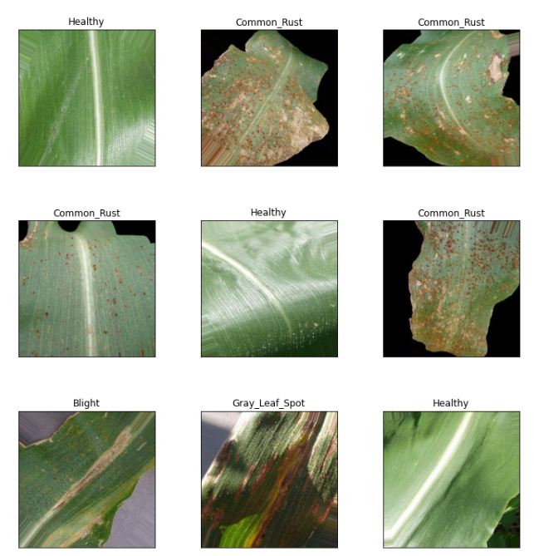
Fig.2. Examples of each category's images from the dataset

- Data Augmentation
The process of data augmentation formation was previously described (R. Dhivya and N. Shanmugapriya, 2023). The quantity of each form of leaf image fluctuates; therefore the model may deviate after training under various types if the distribution of image types is not balanced. The amount of different image types can be balanced, the training set can be increased, images can be made more realistic, and overfitting can be prevented from making the model more sensitive to noises or minute features than the underlying relationships we seek. The field's foliage creates a variety of sharpness and resolution variations in the photos. Together with random shadows and dazzling flecks on the leaves, uneven sunlight exposure causes these effects.
As a result, we used data augmentation techniques to increase training accuracy and minimize overfitting. The often used techniques include color jitter, fixed angle rotation, and picture transformation. In this paper, data augmentation techniques include horizontal picture transformation, image rotation, contrast, and brightness. We adopt the technique of 90-180 degree rotation to prevent losing a portion of the image edge when rotating. The outcomes of the data augmentation for maize leaves are displayed in figures 3 and 4.

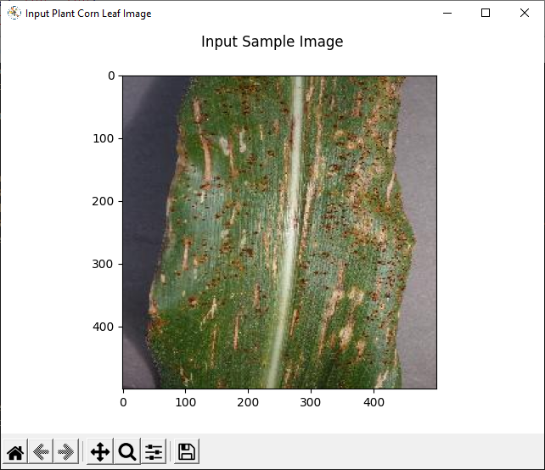

Fig.3. Input Sample Corn Gray Spot disease Image
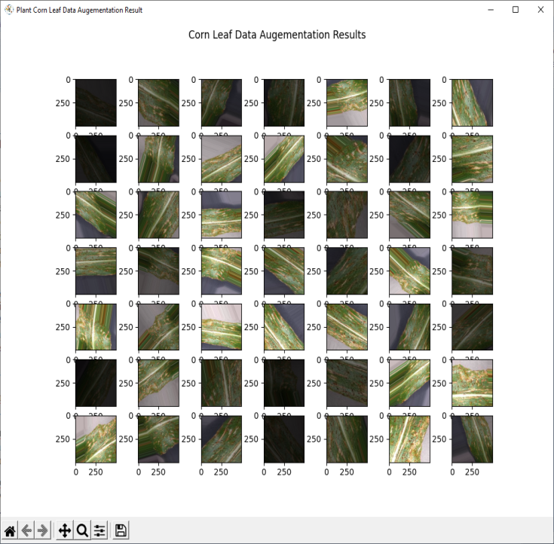
Fig.4. Corn leaf Data Augmentation Result

- Enhanced EfficienNET with BiLSTM Classification
The identification and prediction of corn or maize leaf diseases are done using the Enhanced EfficientNET with BiLSTM (ENETBiLSTM) classification. In humid, warm settings, the diseases are more prevalent. Hence, in reducing the damage, early diagnosis of these disorders is essential. This paper's main objective is to classify various diseases using Efficientnet and LSTM method. Deep learning architectures are designed to provide more effective methods using fewer models. EfficientNet, in contrast to additional cutting-edge models, produces extra effective results by always increasing depth, width, and resolution while leveling the form down. The primary step in the complex scaling method determines how the different scaling dimensions of the baseline network relate to one another under a fixed resource restriction is the search for a grid.
In compound scaling, depth, width, and resolution are equally scaled using the compound coefficient and the guidelines in Eq. 1.
$$\left\{\begin{aligned}depth:dp=α^{φ} \\ width:wd=β^{φ} \\ resolution:rs=γ_{φ}\end{aligned} (1)\right.$$
Where 𝛼 ≥ 1, 𝛽 ≥ 1, 𝛾 ≥ 1 the supplied values wd, dp, and rs can be used to scale the network's width, depth, and resolution coefficients, and the constants, and can be used to assign these resources to the network's depth, width, and resolution in three dimensions, respectively. With a single output, the BiLSTM connects two hidden layers that are moving in the opposing directions. This property of BiLSTM allows it to read an image's features along both directions and time steps, which enhances performance on sequence classification problems. Sequential modeling can take use of long-range context dependencies in both the past and the future time steps by combining both Bidirectional RNN and LSTM.
In order to improve classification performance, recurrent property has been added to the conventional EfficientNet structure using this proposed technique’s combined combination of EfficientNET and BiLSTM. The BiLSTM is used to interpret the derived features across time steps once they have been extracted using the EfficientNETB0. The proposed ENETBiLSTM classification results described in figure 5.

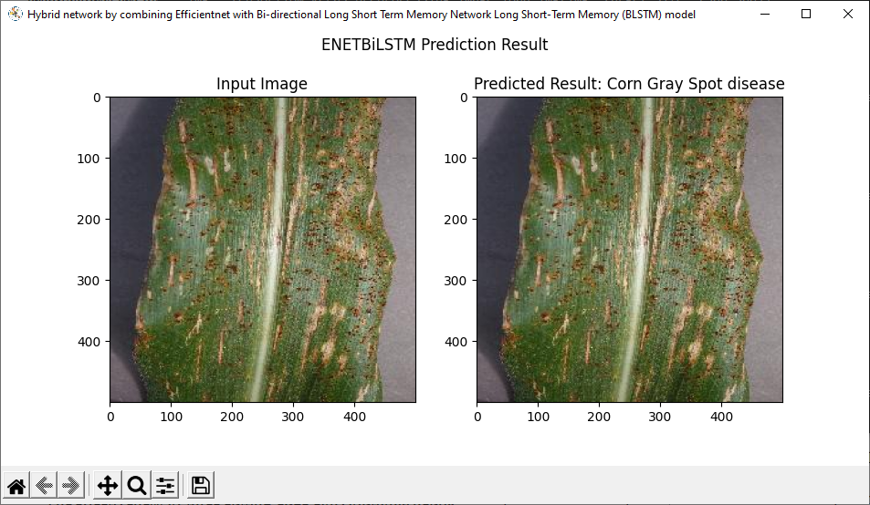
Fig.5. ENETBiLSTM classification result
IV. Experimental Results
The results have been approximated using the ENETBiLSTM method that has been suggested. The outcomes were implemented on a machine running Windows 10 using Python 3.7 model, with Intel processor I3-2500 operating 3.81 GHz and 4GB of RAM. To illustrate this paper's points, real-world examples are presented. The complete ENETBiLSTM training and validation accuracy and loss is illustrated in figures 6 and 7.

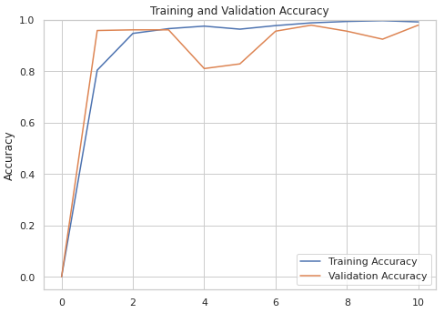

Fig.6. Accuracy Chart

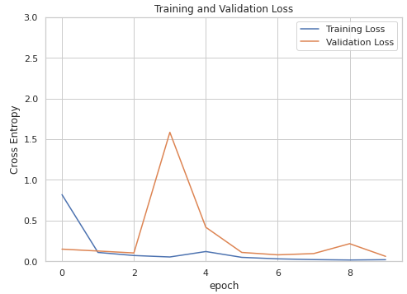
Fig.7. Loss Chart
V. Conclusion and Future Work
In this paper, focus on categorizing different corn plant diseases using both local and global factors. With the help of the ENET-BiLSTM model, we have deployed a new hybrid deep learning technique to extract all features as well as to determine the spatial contextual meaning of the derived features. A corn disease image's edge, ridges, and other significant features can be extracted with the help of EfficientNET. By providing a time distribution layer that allows for numerous operations on the same layer or layers, the BiLSTM model creates association between the extracted attributes. A series of “image interpretations” or “image features” are provided by this depiction. This model's evaluation accuracy was 99.989%, which suggests that it is very persuasive.
REFERENCES

- Storey, G.; Meng, Q.; Li, B. Leaf Disease Segmentation and Detection in Apple Orchards for Precise Smart Spraying in Sustainable Agriculture. Sustainability 2022, 14, 1458. [CrossRef]
- Mahlein, A.K. Plant Disease Detection by Imaging Sensors–Parallels and Specific Demands for Precision Agriculture and Plant Phenotyping. Plant Dis. 2016, 100, 241–251. [CrossRef] [PubMed]
- Kumar, K.K.; Goddu, J.; Prasad, P.S.; Senthilrajan, A.; Rao, L.V.K. An Efficient Approach for Identification of Multi-plant Disease Using Image Processing Technique. In Computer Networks, Big Data and IoT; Springer Nature: Singapore, 2022; pp. 317–325. [CrossRef]
- Rahman, C.R.; Arko, P.S.; Ali, M.E.; Khan, M.A.I.; Apon, S.H.; Nowrin, F.; Wasif, A. Identification and recognition of rice diseases and pests using convolutional neural networks. Biosyst. Eng. 2020, 194, 112–120. [CrossRef]
- Manvi, G.G.; Gayana, K.N.; Sree, G.R.; Divyanjali, K.; Patil, D.K. Plant Disease Detection. Int. J. Res. Appl. Sci. Eng. Technol. 2022, 10, 4538–4542. [CrossRef]
- Barbedo, J.G.A. A review on the main challenges in automatic plant disease identification based on visible range images. Biosyst. Eng. 2016, 144, 52–60. [CrossRef]
- J. Al-doski, S. B. Mansor and H. Z. M. Shafri, “Image Classification in Remote Sensing,” Journal of Environment and Earth Science, vol. 3, no. 10, pp. 141-147, 2013.
- J. Deng, W. Dong, R. Socher, L.-J. Li, K. Li, and L. Fei-Fei, ``ImageNet: A large-scale hierarchical image database,'' in Proc. IEEE Conf. Comput. Vis. Pattern Recognit., Jun. 2009, pp. 248-255.
- A. F. Agarap, ``Deep learning using rectied linear units (ReLU),'' 2018, arXiv:1803.08375.
- R. Hu, S. Zhang, P. Wang, G. Xu, D. Wang, and Y. Qian, “The identication of corn leaf diseases based on transfer learning and data augmentation”, in Proc. 3rd Int. Conf. Comput. Sci. Softw. Eng., May 2020, pp. 58-65.
- E. L. da Rocha, L. Rodrigues, and J. F. Mari, ``Maize leaf disease classication using convolutional neural networks and hyperparameter optimization,'' in Proc. Anais do XVI Workshop Visão Computacional. (SBC), 2020, pp. 104-110.
- Buja, I.; Sabella, E.; Monteduro, A.G.; Chiriacò, M.S.; Bellis, L.D.; Luvisi, A.; Maruccio, G. Advances in Plant Disease Detection and Monitoring: From Traditional Assays to In-Field Diagnostics. Sensors 2021, 21, 2129.
- Xu, Y.; Zhao, B.; Zhai, Y.; Chen, Q.; Zhou, Y. Maize Diseases Identification Method Based on Multi-Scale Convolutional Global Pooling Neural Network. IEEE Access 2021, 9, 27959–27970/
- Storey, G.; Meng, Q.; Li, B. Leaf Disease Segmentation and Detection in Apple Orchards for Precise Smart Spraying in Sustainable Agriculture. Sustainability 2022, 14, 1458.
- Amin, H.; Darwish, A.; Hassanien, A.E.; Soliman, M. End-to-End Deep Learning Model for Corn Leaf Disease Classification. IEEE Access 2022, 10, 31103–31115.
- R. Dhivya, N. Shanmugapriya. “Multi-class Plant Leaf Image Disease Prediction Using Deep Learning Algorithm”, 2022 International Conference on Knowledge Engineering and Communication Systems (ICKES), 2022.
- Plant Village Dataset. Accessed: Jul. 9, 2021. [Online]. Available: https://www.kaggle.com/saroz014/plant-diseases

