DCBD: An Efficient design of Dynamic Compromise Black Hole Attack Detection (DCBD) in WSN
¹S. Shanmugapriya | ²N. Shanmugapriya
Research Scholar, Department of Computer Science | Associate Professor & Head, Department of Computer Applications (PG),
Dr.SNS Rajalakshmi College of Arts and Science,. | Dr. SNS Rajalakshmi College of Arts & Science,
Coimbatore-49 | Coimbatore - 49.
charanmum@gmail.com | spriyanatrajan@gmail.com

Abstract— In numerous fields, including environment monitoring, combat surveillance, and other uses, wireless sensor networks are widely employed. The data packets must be forwarded to the base station in each of these applications by a collaboration of the numerous sensor nodes. But it uses up the several capacities of a sensor node, including the battery, the storage, and the computational power. Using a technique called clustering, which groups sensors with similar characteristics under the control of a chosen sensor known as a Cluster Head (CH), wireless sensor networks (WSNs) can communicate more effectively. The Dynamic Compromise Black Hole Attack Detection (DCBD) algorithm is a novel method that this paper introduces to improve the throughput and network longevity of WSNs. The sensor network is segmented into a fair clustering in DCBD. Additionally, the CH selection for each location is determined by the sensor's energy, the distance to neighbors, and the distance to the base station. The performance of DCBD and other techniques have been compared using simulation studies, and the findings show that DCBD meets the design goals in terms of throughput, latency, and packet delivery ratio.
Keywords— Clustering, WSN, Black-hole attack, Cluster Head, AODV.

Introduction
To agreeably perceive physical or environmental circumstances, a WSN is made up of independently placed sensor nodes that are spatially appropriate. The core function of these networks is data collection, and the data they acquire are extremely related with the end user [1, 2]. Wireless communication among the deployed sensor nodes and the base station is frequently attempted. A wireless sensor network's general topology is depicted in Figure 1. The WSN, which enables dependable monitoring of any applications, may consist of hundreds or even more nodes. Directly or in a multi-hop fashion, the sensed data are sent to the base station. The base station has a wired connection, allowing for the storage of data in significant databases for later use.

BS
Server
End User
End User

Internet
Sensor Nodes

- A Wireless Sensor Network
As of late, target tracking, biological health monitoring, and environmental monitoring are just a few of the areas where wireless sensor networks (WSNs) are being extensively deployed. In order to increase the lifespan of WSNs, cluster-based routing is a resource-efficient method [3, 4]. Usually, a specified number of clusters and a sink node make up the clustered WSNs. In most clusters, a cluster head (CH) node and a few cluster member (CM) nodes are present. In cluster-based WSNs, the CHs often play a crucial role because they are in charge of collecting the data from the CMs in the same cluster as the CH, processing it, and either sending it directly to the sink or using multi-hop routing by other CHs [5] or other CHs [6] to transmit it to the sink. In Figure 2, a traditional cluster framework is displayed. As can be seen, the mobile nodes are divided into a number of functional groups (shown by the scattered lines) according to predetermined principles. Mobile nodes may be given a particular role or responsibility inside a cluster structure, such as cluster head, member, or gateway.

CH
CM
Outside cluster Communication
Cluster Boundaries
Inside cluster Communication

- A traditioanl cluster framework [7]
The explicit use of WSNs is accompanied by a number of security concerns [8-11]. Prevention-based systems are unable to address all of these security challenges. It is necessary to execute the detection-based supplement requirements as a result [12-13]. Because of the limited resources, routing in WSNs is more difficult to execute when compared to ad-hoc networks [14]. The restricted bandwidth, memory, and processing capabilities have been included into nodes in WSNs. The routing methodology, which is an effective strategy for utilizing resources, must be used [15–17].
In this paper, presents a Dynamic Compromise Black-hole attack Detection (DCBD) algorithm in cluster based wireless sensor network.
These are the three contributions that have been proposed:
- Network model generation
- Cluster Head formation.
- Dynamic Compromise Black hole attack Detection (DCBD) algorithm.
The remainder of the paper is structured as follows: Sect. 2 provides specifics on Related Work. The proposed approaches for the DCBD process were explored in Section 3; the experimental findings are given in Section 4. Sect. 5 contains the conclusion and recommendations for further work.

Related Work
Wei, et al. (2011) [18] identified a problem that occurs frequently in data collection scenarios where Cluster Heads (CH) bear a significant burden of information gathering and dissemination. Particularly when the distance to the sink reduces, the relay burden on CHs increases. The authors introduced the Energy-efficient Clustering (EC) distributed clustering method, which approximates equalization of node lives and lower levels of energy consumption while selecting suitable cluster dimensions based on the hop distance to the data sink.
(Abhinav Kaurav and Kakelli Anil Kumar, 2017) [19] discussed to assess environmental factors. WSN is a network of tiny sensor nodes built of semiconductor devices spread across a vast geographic area. These networks are quite vulnerable to security breaches. Numerous security risks in wireless sensor networks are brought on by the installation of sensor nodes in a specific area without supervision. In order to protect WSN from a blackhole assault, the authors created a preventative technique. To recognize and stop this attack in the NS-2.35 simulator, they exploited the well-known AODV protocol technique.
According to the proposed strategy by S. Althunibat and R. Mesleh (2018) [20], just one node reports all local choices made by cluster members to the central entity. In contrast to conventional clustering, the reporting node is not constant because it changes depending on the local decisions made. As a result, two groups of local decisions are made by each cluster member. The first one modulates while the second one establishes the reporting node's index. An upper bound is developed after analysis of the proposed scheme's judgement error rate. At real-world signal to noise ratio values, it is demonstrated that the calculated bound closely matches simulation results.
Alghamdi (2020) [21] noted how it is therefore difficult to improve data dissipation in an energy-efficient way in order to lengthen the lifespan of sensor devices. The clustering strategy, which has already been proven, may be used to increase or lengthen the life of WSNs. The choice of the CH in each cluster is regarded in the clustering model as the effective technique for energy-efficient routing, which reduces the transmission latency in WSN. In this case, the authors made an effort to create a novel clustering model with the best cluster head selection by taking into account four key factors: energy, latency, distance, and security.
State-of-the-art technologies are on the horizon as a result of innovation, and its ramifications in a variety of disciplines were examined by A. Srivastava and P. K. Mishra in 2022. [22] Energy usage and wireless sensor networks, which play essential roles in this field, are also major concerns. Clustering is one of these crucial methods for effective energy use. The authors suggested to choosing Cluster Heads (CHs) based on Multi-Attribute Decision Making (MADM) to extend network lifetime and reduce energy usage.
Table 1 gives brief summary of different clustering techniques in WSN with different advantages, results and limitations.

Methods | Comparison of different Cluster based network efficiency
Methods | Technique | Advantages | Results | Limitations
[19] | Blackhole Attack Mechanism in the AODV Protocol | To identify and stop a black-hole attack | PDR 98.25%. | How to prevent the WSN in various other new protocols.
[20] | Index Modulation | Analysis of the suggested scheme's decision error rate results in the development of an upper bound. | Error rate is 0.75% | The low-complexity receivers are not performed.
[21] | Optimum cluster head selection in a new clustering model | Improved lifespan and structural data flow. | Computational Time is 9102 seconds | Computational cost is high.
[22] | MADM | Increase Network lifetime. | Throughput 80.9% | How to make the WSNs' hierarchical routing protocol function better.

Utilizing the network's limited energy resources effectively is one of Wireless Sensor Networks' (WSNs') main issues, as illustrated by Madhu et al. (2022) [23]. Most of the time, sensors' energy units cannot be changed or supplied. So there is always a need for reliable, energy-efficient load balancing algorithms in WSNs.

Methdology
The aim of the proposed approach is to discover black hole attacks on cluster-based wireless sensor networks and shield them from harm using Dynamic Compromise Black hole attack Detection (DCBD) algorithm. This system modifies the AODV routing protocol by adding the idea of false RREQ packets. Before the real route discovery, the bogus RREQ packets are disseminated throughout the network. To avoid data loss, this is done so that the majority of rogue nodes in the network can be located before any data is transmitted. Before getting into more depth about the technique, a modification of the routing protocols is offered to guarantee discontinuous routes. AODV is modified as follows to guarantee discontinuous control message paths: Every intermediary node that collects the RREQ adds its position to the requests once the source broadcasts it, and then broadcasts it to its neighbors once again. This procedure is repeated up until the sink node was used. The sink node establishes discontinuous pathways in response to the source node's request to send data over the chosen paths. The proposed flow design for DCBD is shown in Figure 3.

NS 2.34 Simulator
Network model Generation
Cluster Head Selection process
Results
Next Cluster Head Selection process
DCBD
CM Black-hole attack list
Searching path
AODV Routing
CH Time
Black-hole attack formation

Network parameters

- DCBD Flow Diagram

Network Model Generation
Every sensor node is subjected to algorithm 1 network model creation operation, which produces a model customized to each parameter of the node displayed in the interval table. The network model result screen is described in figure 4. In this approach, the ranges of a set of values whose node parameters are related to them are determined by predetermined threshold values. A sensor node's relative mobility state is represented by the first model, which is used to represent the current energy consumption ratio state. The second model is used to represent the success packets ratio.
Algorithm1: Network Model Generation
Input: Wireless Sensor Nodes WI analysis, interval table IT, Linking table LT
Output: Node Analysis (N_{a})
Process
Step 1: For k=1 to m // initially for all nodes
Initialize Node Analysis N_{a} = 0, Success Analysis S_{a} = 0
End for
Step 2: Declare interval [I] and critical value based on interval value received for Base Station (BS).
Step 3: For k=1 to m //Each node calculates parameter
$$Energy Ratio (ER) = \frac{\sum_{i=1}^{m}{{Energy_Consumed}_{i}}}{{Resudial_Energy}_{i}}×100$$
$$Success_Packets (SP) = \frac{\left[TP-(DP+RP)\right]}{TP}×100$$
//Where TP- Total amount of packets transmitted; DP - Amount of packets discarded; RP- Amount of packets re-transmitted.
End for
Step 4: Find the respective critical value for each parameter using interval and critical values of Interval table (IT)
Step 5: Find the possible model from linking table using critical value (i.e, low, medium or high) of each parameter
Step 6: End process

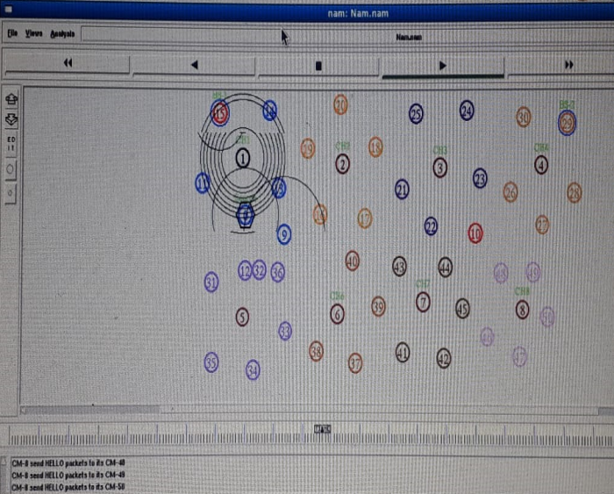
- Network Model Generation

Cluster Head Selection
Following the creation of the network model, each sensor node decides whether to become a Cluster Head (CH) or not. By delivering a Control message (i.e., Hello packets) to its neighbor, each node whose Network model is active can participate in the CH selection. The node id, energy generated in this round and time stamp are all contained in this packet. A CH is initially selected at random from one node. Then, each node compares its node analysis to this CH node that was chosen at random. If their analysis outperforms the chosen CH node, this node is chosen as a CH. This procedure is repeated until the CH selection has been verified for all nodes whose CH is active. The cluster head selection result is shown in figure 5.
Algorithm 2: Cluster Head (CH) selection
Input: N_{a}
Output: CH node
Begin Process
Step 1: Initialization Network Model analysis (N_{a})
Step 2: (Node₁) = CH // initially one node chosen itself as a CH
Step 3: For k=1 to m //ensuring the presented Sensor nodes
If (Node_{k} → N_{a} < Node_{k+1}) then
Node_{k+1} == CH
End if
End for
Step 4: CH → N_{a} +[Time] + [ Node_{id}] //CH board cost itself as CH along with N_{a}, timestamp and node ID
Step 5: (Node_{k-CH}) = Ordinary sensor node //Remaining sensor node declares itself as an ordinary sensor node
End Process
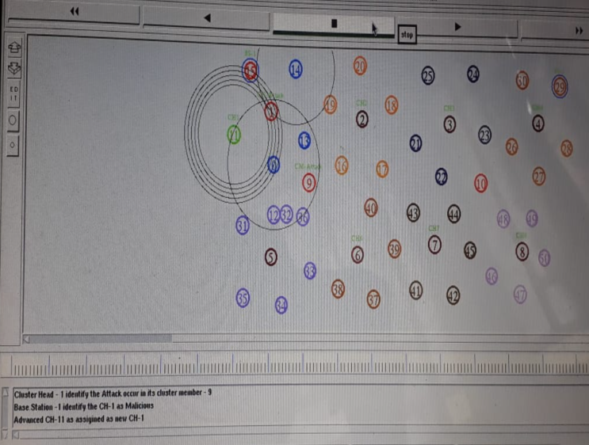
- Clsuter head selection result

Dynamic Compromise Black hole attack Detection (DCBD)
The source node generates false RREQ packets throughout the network prior to beginning the true AODV route discovery procedure. A bait timer is embedded in the source node, and its value is set arbitrarily to A seconds. The source node generates a fake RREQ packet and broadcasts it into the network whenever the timer reaches seconds, along with a randomly generated false destination address. The same working method used by the RREQ packet of the AODV is used by DCBD to prevent the network from being overrun by bogus RREQ packets. There is a time limit on the life of the fake request packet. The black hole node quickly responds to all RREQ packets it receives, appearing to have the quickest path to the target node, while simultaneously responding to all request packets without consulting its routing table for appropriate routes. The source node interprets all RREPs as having been sent by malicious nodes after it receives the responses to the fake RREQ packets.
In a Black-Hole attack, data packets are promised to be routed to the Base Station (BS) node, which fraudulently claims to have the quickest path but really drops every packet, endangering network dependability. A Black-Hole is a malicious node that loses all packets being received and falsely responds to Route Requests (RREQ) without having an active route to the provided BS. Such compromised nodes will inflict substantially more harm as a group if they cooperate. Cooperative Black-Hole (BH) attack is another name for this type of attack. The primary goal of the suggested strategy is to locate the compromised sensor node and stop it from interfering with network traffic. If a compromised node is chosen in either of the two attacks under discussion as a CH that aggregates data from Cluster Member (CM) nodes of the cluster, it may undoubtedly reduce that node's energy unnecessarily, which will negatively impact the lifetime of the sensors in each round of the CH selection mechanism and, consequently, the entire WSNs.

Algorithm 3: Detection and Prevention of CH Black-Hole attacks
Input: N_{a}
Output: Intermediate CH node
Begin Process
Step 1: Initialization Network Model analysis (N_{a}) using Algorithm 1
Step 2: CH selection using Algorithm 2
Step 3: For k=1 to m //ensuring the presented Sensor nodes
Each CH broadcast RREQ packets to CM
Intermediate CH Node receives RREP, Routing Information.
End for
Step 4: IF received timestamp of RREP by Intermediate_{CH} < threshold_factor then
Intermediate_{CH} = Attack
Remove Routing information of Intermediate_{CH} from CH Routing Table
Else
Route Data Packets to Intermediate_{CH}
Present_IntermeidateNode =Next Hop node CH.
End if
Step 5: IF Target_Node_{CHsequence} > final(Target_Node_{CHsequence}) || NodeCountLast(Target_Node_{CHsequence}) > TF_BH then
Intermediate_{CH} = Attack
Remove Routing information of Intermediate_{CH} from CH Routing Table
Else
Route Data Packets to Intermediate_{CH}
Present_IntermeidateNode =Next Hop node CH.
End if
Step 6: IF Intermediate_{CH} == Compromised Node then
Broadcast advance request to Next Hop node CH
End if
Step 7: Receive Advanced request and routing information of requested Next Hop node CH
Step 8: IF Intermediate_{CH} =! Attacker Node then
Route data packets to selected Next Hop node CH
End if
End Process

After a certain amount of time has passed, the CH receives the data from each CM. All nodes communicate their remaining energy information to the CH to become a CM for the following round after a round has ended. is the cutoff for the number of packets received at CH (α = 0 in the case of a blackhole), and CH is the group of CH’s for the present round. The result is shown in figure 6.
Algorithm 4: Detection and Prevention of CM Black-Hole Attacks
Input: N_{a}, Attack-list = 0
Output: CM Blackhole Attack list
Begin Process
Step 1: Initialization Network Model analysis (N_{a}) using Algorithm 1
Step 2: CH selection using Algorithm 2
Step 3: For k=1 to m //ensuring the presented Sensor nodes
Each CH broadcast RREQ packets to CM
CH receives RREP, Routing Information.
End for
Step 4: For p=1 to t // presented as CM nodes
CM Packets sent (CM_{p}) = No. of packets forwarded to CH/ RREQ_Time
If (t = time_{round} ) then
IF (CM_{p} <= α) then
Flag_{p} = Flag_{p} +1
End if
End if
IF (time_{round} = time_{CH})
IF (Flag_{p} == 0 && CM_{p} < avg (CH_{pakcetCount}))
Attack A_{p} = CM_{p}
Attack-list = {Attack-list} ∪ A_{p}
Else
Attack A_{p} = 0
End if
End if
End for

End Process

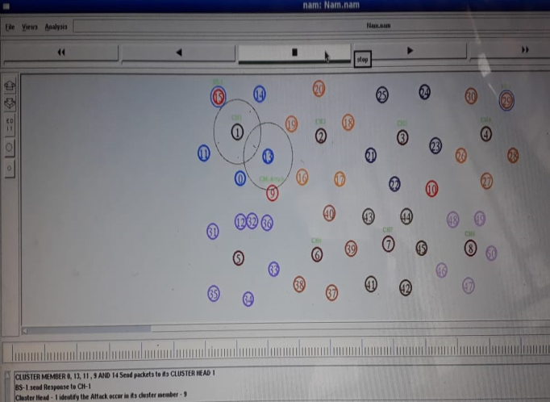
- Black-hole attack detection and prevention result

Experimental Results
The proposed system believes 100 to 500 nodes Dynamic Compromise Black hole attack Detection (DCBD) in Cluster based wireless sensor networks, with nodes randomly deployed in a 1000 m × 1000 m area. The outcomes were implemented on a machine running Fedora operating system using NS2.34 simulator model. The simulation parameters are given in table 2.
Table 2: Simulation parameters
 | SYMBOL | VALUE
Mobile Nodes | MN | 5-50 in steps of 10
Simulation Area | Row × Column | 300 × 300
Transmission Range | TR | 5-50 in steps of 10
Node Energy | E_{node} | 100Joules
Boosting Energy | E_{boost} | 100J/bit/m²

The following factors were taken into consideration: throughput, latency, packet delivery ratio in order to demonstrate the significance of the suggested strategy of existing DSIDS [24], FIDS [25], NSABO [26], MTBD [27] and proposed DCBD model shown is tables 3 to 5 and chart in figures 7 to 9.
Table 3: Throughput
Methods | 100 | 200 | 300 | 400 | 500
DSIDS | 3149617 | 3110567 | 3068492 | 3017808 | 2962879
FIDS | 1200235 | 1199316 | 1198934 | 1197893 | 1197117
NSABO | 999622 | 974376 | 944088 | 908121 | 868428
MTBD | 3800366 | 3792175 | 3782606 | 3769580 | 3756476
Proposed DCBD | 4000156 | 3811445 | 3974006 | 3864570 | 3943572

- Throughput Chart
Table 4: latency
Methods | 100 | 200 | 300 | 400 | 500
DSIDS | 230 | 233 | 235 | 234 | 236
FIDS | 250 | 250 | 252 | 253 | 253
NSABO | 202 | 205 | 205 | 207 | 209
MTBD | 190 | 194 | 196 | 196 | 196
Proposed DCBD | 187 | 188 | 188 | 186 | 185

- Latency Chart

Table 5: Packet Delivery Ratio
Methods | 100 | 200 | 300 | 400 | 500
DSIDS | 90 | 88 | 87 | 86 | 86
FIDS | 90 | 89 | 89 | 87 | 87
NSABO | 87 | 85 | 84 | 84 | 82
MTBD | 98 | 96 | 96 | 94 | 94
Proposed DCBD | 98 | 98 | 97 | 96 | 95

- PDR Chart

Conclusion and Future work
To improve throughput, latency, and packet delivery ratio while taking the CHs selection process into account, a new clustering approach called Dynamic Compromise Black hole attack Detection (DCBD) has been proposed in this paper. Black hole node detection in its early phases is crucial for preventing network breakdowns. In the suggested DCBD procedure, a straightforward and creative mechanism is used to draw the black hole nodes early on in the process in order to detect them in an AODV-based Cluster WSN. Throughput (3918749.8 kbps), latency (186.6 ms), and packet delivery ratio (96.8%) are the average values obtained for all the metrics taken into consideration. The throughput, latency, and PDR of the proposed method are significantly superior than those of current state-of-the-art methods, according to simulation findings. To further develop the suggested methodology in order to increase throughput and packet delivery ratio while lowering latency.

References

- Y. Ozturk and V. Nagarnaik, \A scalable distributed dynamic address allocation protocol for ad-hoc networks," Wireless Networks, vol. 17, no. 2, pp. 357{370, 2011.
- R. Rout and S. Ghosh, \Enhancement of lifetime using duty cycle and network coding in wireless sensor networks," IEEE Transactions on Wireless Communications, vol. 12, no. 2, pp. 656{667, 2013.
- X. Liu, “A survey on clustering routing protocols in wireless sensor networks”. Sensors 2012, 12, 11113–11153.
- B. Jan, H. Farman, H. Javed, “ Energy efficient hierarchical clustering approaches in wireless sensor networks”: A survey. Wirel. Commun. Mob. Comput. 2017, 2017, 6457942.
- X. Zhang, Y. Ding, G. Yao, K. Hao, K, “An adaptive clustering routing algorithm for energy harvesting-wireless sensor networks”. In Proceedings of the 2016 IEEE Congress on Evolutionary Computation (CEC), Vancouver, BC, Canada, 24–29 July 2016.
- W.R. Heinzelman, A. Chandrakasan, H. Balakrishnan, “Energy-efficient communication protocol for wireless microsensor networks”. In Proceedings of the 33rd Annual Hawaii International Conference on System Sciences, Maui, HI, USA, 4–7 January 2000.
- R. Jayaprakash and B. Radha, "LBCPR: Load Balancing Cluster Based Privacy Routing in Wireless Networks," International Conference on Recent Trends in Automation (ICRTA-18), November 2019.
- Tomić, Ivana, and Julie A. McCann. “A survey of potential security issues in existing wireless sensor network protocols”. IEEE Internet of Things Journal 4, no. 6 (2017): 1910-1923.
- Zhao, Nan, F. Richard Yu, Ming Li, Qiao Yan, and Victor CM Leung. “Physical layer security issues in interference-alignment-based wireless networks.” IEEE Communications Magazine 54, no. 8 (2016): 162-168.
- X. Ding, X. J. Sun, C. Huang, and X. B. Wu, “Cluster-level based link redundancy with network coding in duty cycled relay wireless sensor networks,” Computer Networks, 99(C), 2016, 15–36.
- Akram, Vahid Khalilpour, and Orhan Dagdeviren. “Deck: A distributed, asynchronous and exact k-connectivity detection algorithm for wireless sensor networks.” Computer Communications 116 (2018): 9-20.
- Mehetre, Deepak C., S. Emalda Roslin, and Sanjeev J. Wagh. “Detection and prevention of black hole and selective forwarding attack in clustered WSN with Active Trust.” Cluster Computing 22, no. 1 (2019): 1313-1328.
- Chen, Wei, Derui Ding, Hongli Dong, and Guoliang Wei. “Distributed resilient filtering for power systems subject to denial-of-service attacks.” IEEE Transactions on Systems, Man, and Cybernetics: Systems 49, no. 8, 2019: 1688-1697.
- Xie, Guangqian, and Feng Pan. “Cluster-based routing for the mobile sink in wireless sensor networks with obstacles.” IEEE Access 4 2016: 2019-2028.
- Al-Turjman, Fadi, and Ayman Radwan. “Data delivery in wireless multimedia sensor networks: Challenging and defying in the IoT era.” IEEE Wireless Communications 24, no. 5 (2017): 126-131.
- Z. Teng, M. Xu, and L. Zhang, “Nodes deployment in wireless sensor networks based in improved reliability virtual force algorithm.” Journal of Northeast Dianli University, 2016, 36(2), 86–89.
- Z. Sun, and C. Zhou, “Adaptive cluster algorithm in WSN based on energy and distance.” Journal of Northeast Dianli University, 36(1), 82–86, 2016.

- D. Wei, Y. Jin, S. Vural, K. Moessner, and R. Tafazolli, ‘‘An energyefficient clustering solution for wireless sensor networks,’’ IEEE Trans. Wireless Commun., vol. 10, no. 11, pp. 3973–3983, Nov. 2011.
- Abhinav Kaurav, Kakelli Anil Kumar, “Detection and Prevention of Black hole Attack in Wireless Sensor Network Using Ns-2.35 Simulator” IJSR CSEIT, Volume 2, Issue 3, May – June 2017.
- S. Althunibat and R. Mesleh, ‘‘Index modulation for cluster-based wireless sensor networks,’’ IEEE Trans. Veh. Technol., vol. 67, no. 8, pp. 6943–6950, Aug. 2018.
- T. Alghamdi, ‘‘Energy efficient protocol in wireless sensor network: Optimized cluster head selection model,’’ Telecommun. Syst., vol. 74, pp. 331–345, Mar. 2020.
- A. Srivastava and P. K. Mishra, “Multi-attributes based energy efficient clustering for enhancing network lifetime in WSN’s,” Peer-to-Peer Networking and Applications, vol. 15, no. 6, pp. 2670–2693, 2022.
- S. Madhu, R. K. Prasad, P. Ramotra, D. R. Edla, and A. Lipare, “A location-less energy efficient algorithm for load balanced clustering in wireless sensor networks,” Wireless Personal Communications, vol. 122, no. 2, pp. 1967–1985, 2022.
- K. Vijayakumar and K. Somasundaram, “An effective CBHDAP protocol for black hole attack detection in manet,” Indian Journal of Science and Technology, vol. 9, no. 36, 2016.
- M. I. Talukdar, R. Hassan, M. S. Hossen, K. Ahmad, F. Qamar, and A. S. Ahmed, “Performance improvements of AODV by black hole attack detection using IDS and digital signature,” Wireless Communications and Mobile Computing, vol. 2021, Article ID 6693316, 13 pages, 2021.
- Kanikabawa, “Prevention of black hole attack in MANET using addition of genetic algorithm to bacterial foraging optimization,” International Journal of Current Engineering and Technology, vol. 5, no. No.4 (Aug-2015, pp. 2406–2411.
- Dhanagopal Ramachandran, Sasikumar S ,Vallabhuni Rajeev Ratna, Vijayprasath S, Suresh Kumar R, Vasanth Raj P T, Ilhan Garip, and Umamahesawari K, "A Low-Latency and High-Throughput Multipath Technique to Overcome Black Hole Attack in Mobile Ad Hoc Network (MTBD)", Hindawi Security and Communication Networks, 2022.

